


With a Positive Mindset…I Learn…I Lead…I Succeed!

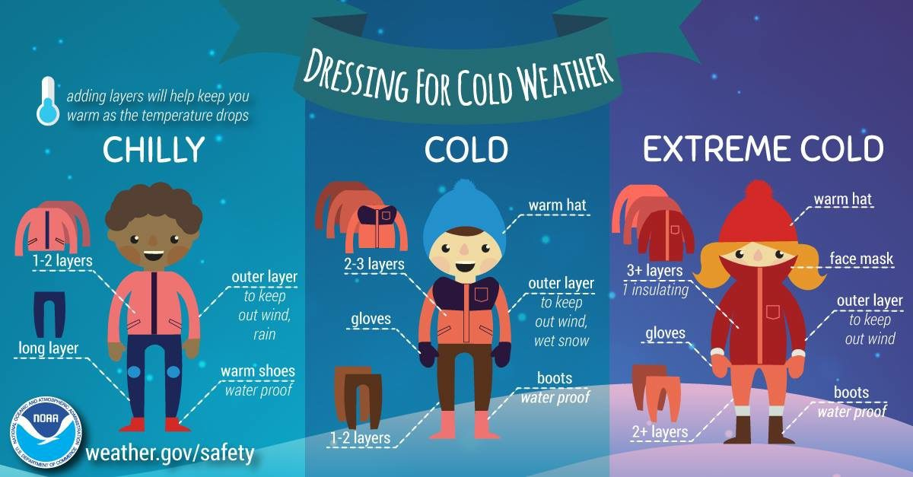

November 10, 2023-
No School-

November 16, 2023-
STEM Night 5pm-7pm

November 20-24, 2023-
No School



As the cold weather season begins please keep the following points in mind when sending your child to school.

- Students should bring a light weight jacket or sweater to wear in class in case they get cold, especially if they are wearing short sleeves.
- Students are asked not to wear their winter coats in class. They overheat and sweat, and then go outside, which breeds germs and is unhealthy.
- We go outside for recess even in winter, so students should dress accordingly, including a hat and gloves/mittens.

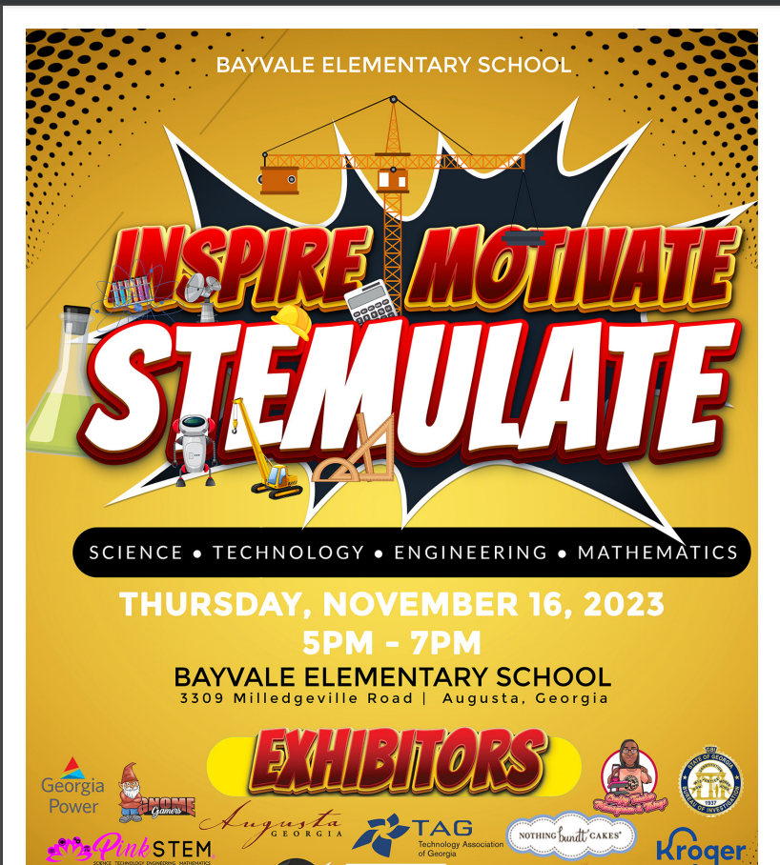

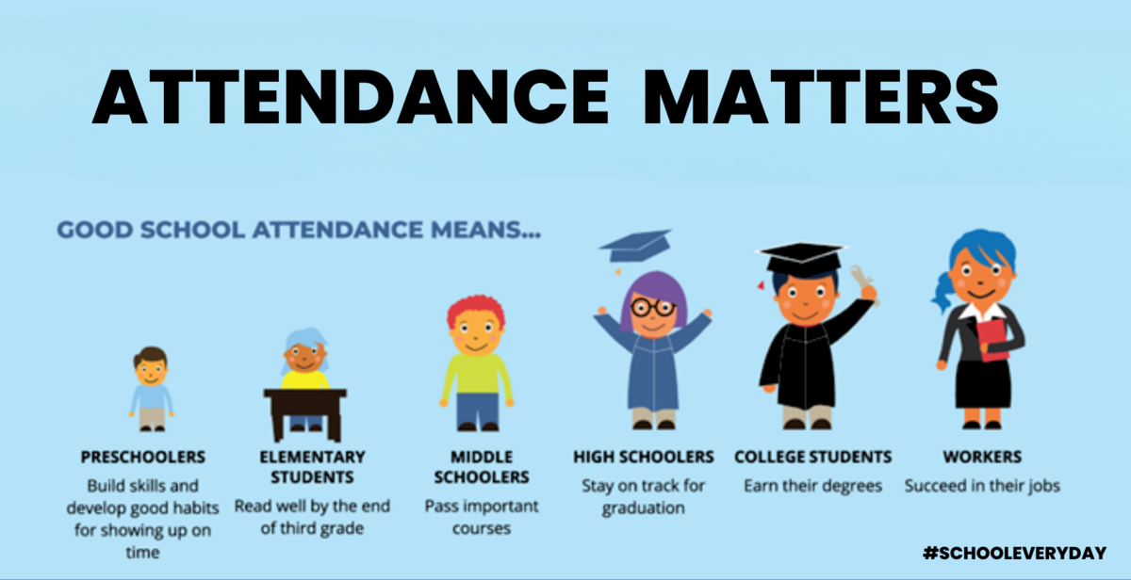
Student attendance is becoming an issue of concern at Bayvale Elementary. Parents, please ensure that your students are present and on time every day. Students who attend school regularly have been shown to achieve at higher levels than students who do not have regular attendance. This relationship between attendance and achievement may appear early in a child's school career.





Mrs. Shaunta Taylor, Principal
Bayvale Elementary School, 3309 Milledgeville Road, Augusta, GA 30909
Phone: 706-737-7255| Fax: 706-737-7256 www.bayvale@rcboe.org

